* Upgrade Visual Studio Community 2019 to Visual Studio Community 2022.

**Click to download Visual Studio community 2022**

* Download .NET 7 SDK from Google and install it on the system.

**Click to download .NET 7.0 SDK (v7.0.401) - Windows x64**

The following products were installed:

* **.NET SDK 7.0.401**
* **.NET Runtime 7.0.11**
* **ASP.NET Core Runtime 7.0.11**
* **.NET Windows Desktop Runtime 7.0.11**
* Then open VS 2022 and select Extensions menu.

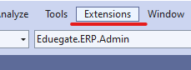

* Click manage extensions.

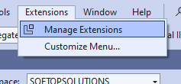

* After open manage extensions then select online and search .NET Upgrade Assistant and click download button, after complete download close visual studio (Need closing of VS to install extensions).

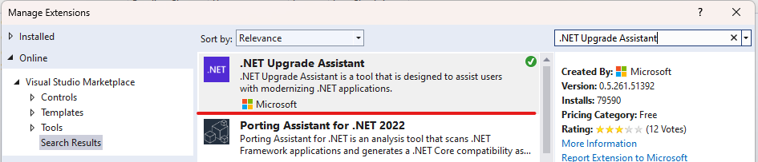

* After close VS then showing a popup window of “VSIX Installer”. At that window click modify button, then installation starts.
* After complete installation reopen VS.
* After installed the .NET Upgrade Assistant extension, right-click on the project in the Solution Explorer window, and select Upgrade.

